……………………………………………………………………………………………………………………………………………………………………………………………………………………………………………………………………………………………………………………………………………………………………………………………………………………………………………………………………………………………………………………………………………………………………………………………………………………………………………………………………………………………………………………………………………………………………………………………………………………………………………………………………………………………………………………………………………………………………………………………………………………………………………………………………………………………………………………………………………………………………………………………………………………………………………………………………………………………………………………………………………………………………………………………………………………………………………………………………………………………………………………………………………………………………………………………………………………………………………………………………………………………………………………………………………………………………………………………………………………………………………………………………………………………………………………………………………………………………………………………………………………………………………………………………………………………………………………………………………………………………………………………….

Introduction to Computer Vision

Learning outcomes

1. You will learn to build image classification models based on convolutional neural networks
2. You will learn how a digital image is stored and how size of digital image is calculated, how images are prepared for modeling
3. You will also learn what is convolution and how it helps extract features from images

Great Lakes Institute of Management

A guide to learn python for analytics

mukhiya1972@outlook.com

**A workbook on Computer Vision in Keras**

**Mukesh Rao**

**Visiting faculty – Great Lakes Institute of Management**

*Copyright @ 2019 Great Lakes Institute of Management : All contents in this book, including (but not limited to) its contents are proprietary to Great Lakes Institute of Management, Chennai. Any effort at re-using, modifying and circulating both through Digital or Physical means, without the express written permission of the author, will amount to infringement of copyrights, and will be liable for suitable action.*

# Table of Contents

1. INTRODUCTION 3

2. Digital images and pixels 4

3. Digitizing process and pixels 6

4. Digital image sizing 8

5. Image as a function with edges as features 12

6. Convolutional Neural Networks 17

7. ANN Vs cnn (Why ANN is not suitable for image processing) 21

8. Convolution Formal Definition 24

9. filters for edge detection 26

10. RELU As NonLinear Activation Function 38

11. Pooling layer 39

12. Fully Connected layer 46

13. CNN in keras … step by step 49

14. CNN architectures 51

15. Transfer learning 63

# INTRODUCTION

1. An image processing involves transforming images in various ways such as : smoothing, sharpening, changing the brightness and contrast, highlighting the edges, and so on.
2. Computer vision, is the ability of computerized systems to take as input an image and output task-specific information such as classification or identification
3. Computer vision systems rely on image processing algorithms to extract the information from images. They use images that are processed by an image signal processor
4. CNNs typically work on pixel intensity value changes as inputs and learn to process them in a way that makes it possible to accomplish a certain computer vision task, such as image recognition.
5. Internal layers of CNNs can be considered as image filters that extract information on different hierarchy levels where higher hierarchy reflects features on large scale. Using this information, they accomplish their tasks

# Digital images and pixels

|  |  |
| --- | --- |
| 1. A digital image d[m,n] described in a 2D discrete space (integral values) 2. It is derived from an analog image a(x,y) in a 2D continuous space through a sampling process a.k.a digitization 3. The 2D analog image a(x, y) is divided into N rows and M columns. The intersection of a row and a column is called a pixel. 4. The value assigned to the integer coordinate of a digital image d[m,n] is a function of physical signal consisting of parameters such as color, depth etc impinging on the sensor in that coordinate 5. The value assigned to every pixel is the average brightness in the pixel rounded to the nearest integer value 6. The process of representing the amplitude of the 2D signal at a given coordinate as an integer value with L different gray levels is usually referred to as amplitude quantization | Sampling |

**Digital Image and Neighborhood**

1. In the digital image processing that we are going to refer to, the processing will involve generating new image from existing image using a transformation process where the values at a pixel in the new image will be dependent on the input values in the neighborhood of the same pixel on the original image. A.k.a localized operations
2. Neighborhood types – defines the way neighbors are identified in the image. The various ways include:
   * 1. Rectangular sampling – Images are sampled laying rectangular grid on the over source image
     2. Hexagonal sampling – Images are sampled laying hexagonal grid over the source image
     3. 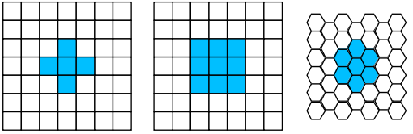In CNN, we will restrict to rectangular grids due to software limitation



1. Digital Image Processing Tools
2. Fourier Transformation & Analysis – to modify representation of one form to another. A 2D signal is transformed to weighted sum of sines and cosines
3. Convolutions – to identify and extract useful features from an image given a task
4. Statistical Distributions & Analysis of the pixel values

# Digitizing process and pixels

**Pixel as light wells**

1. Light is made of photons, smallest energy packets. They carry information from the source
2. On collision with certain types of metals, they produce electrons (photoelectric effect)
3. When they hit the CMOS image sensors in the camera behind the lens, electrons are released from the sensors producing a small electric current.
4. The sensor is a grid of light sensitive pixels and each pixel gathers the free electrons
5. Each pixel well has a maximum capacity of electrons it can collect. This maximum is known as full well capacity.
6. A pixel can only display a single color, including black, white, greyscale, and RGB Color values.
7. The color intensity of each pixel is determined by the amount & kind of light information it collects
8. On completion of the sampling window (shutter close), the electrons collected in each pixel cell is converted to a digital signal representing color and intensity (R,G,B in the range of 0 – 255)

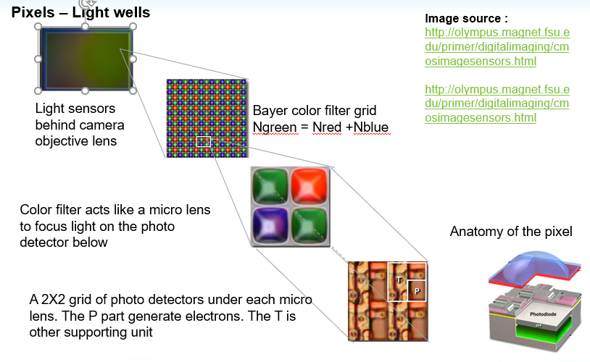

1. Each pixel well collects a number of electrons during the sampling window
2. Pixel brightness = f ( number of electrons collected)
3. Pixel brightness is measured as tonal value on a scale of 0 – 255
4. The more electrons a pixel collects, the lighter it’s corresponding tonal value is
5. A white pixel contains the maximum amount of electrons
6. A black pixel contains no electrons
7. All values between maximum and minimum produce greyscale tonal values
8. The color cannot be determined by electron count. It is determined by which filter does the pixel sit under
9. By combining the tonal value & color filter information, the pixel color and it’s intensity is determined

The closer the number of electrons collected to full capacity, the lighter the pixel gets

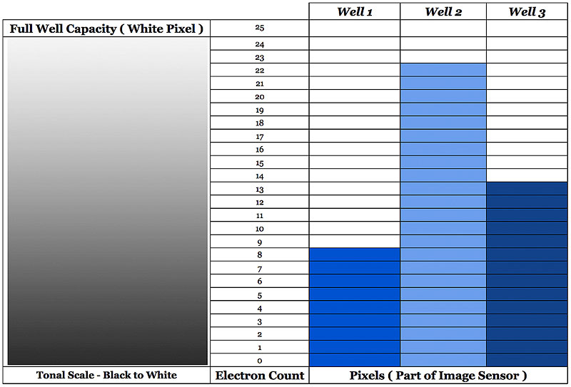

# Digital image sizing

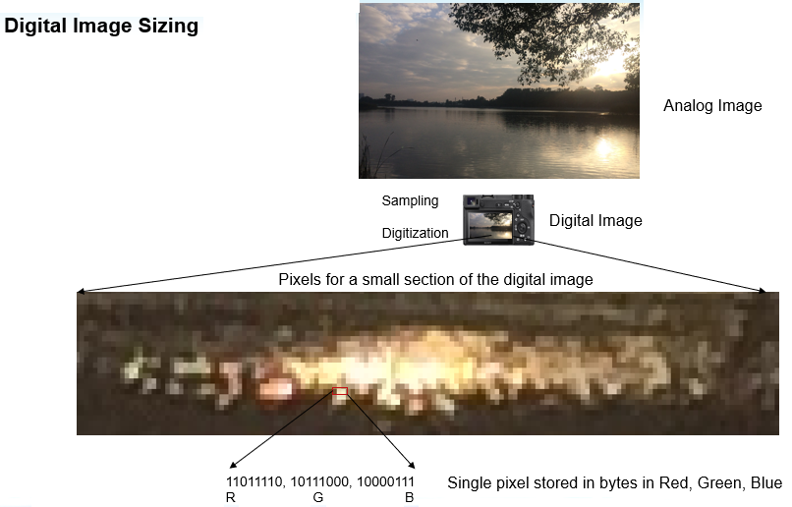

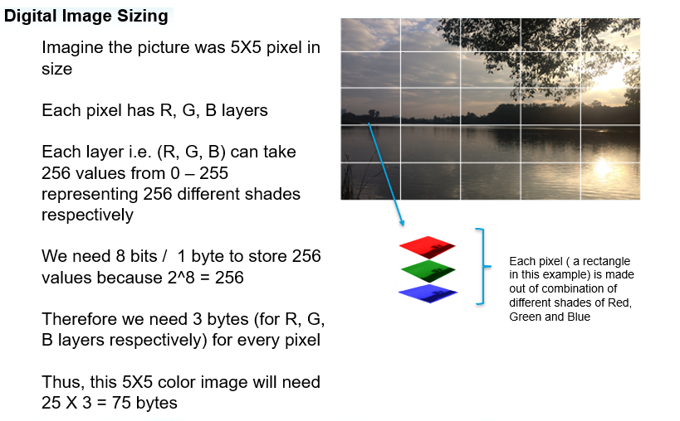

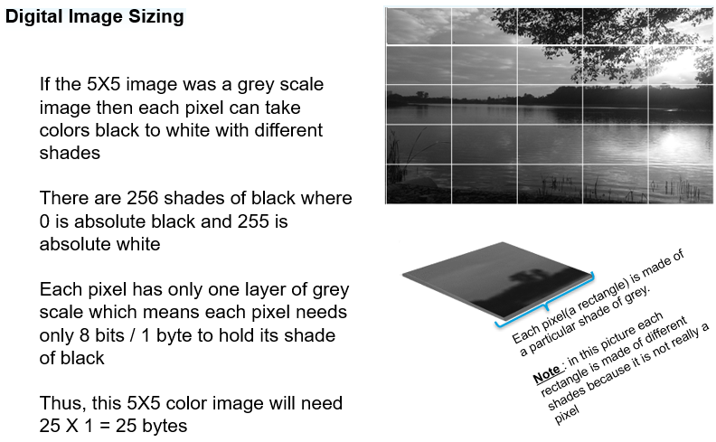

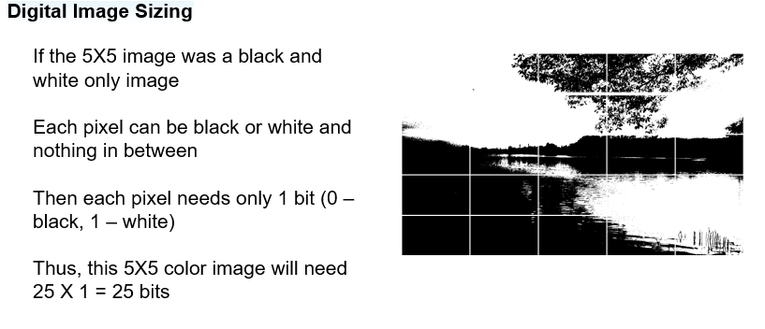

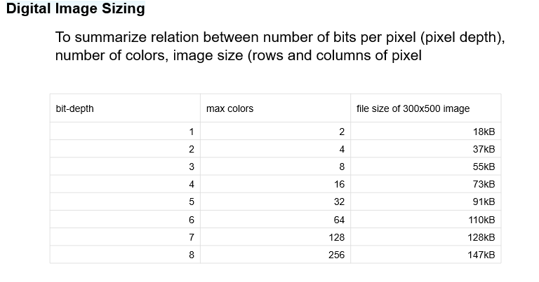

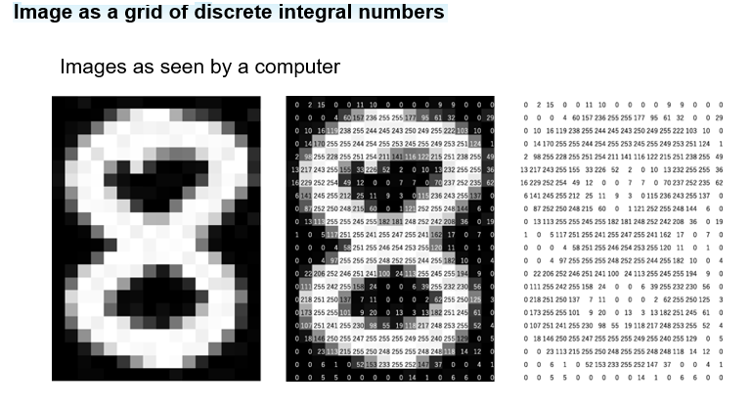

# Image as a function with edges as features

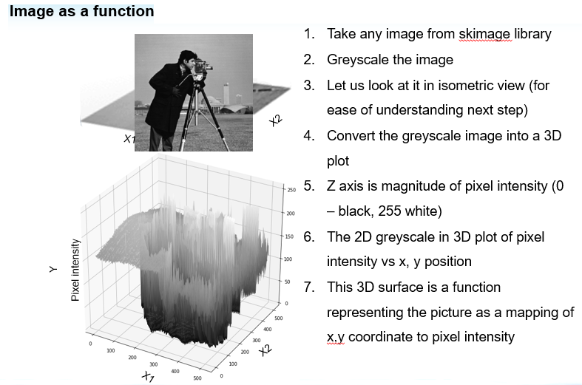

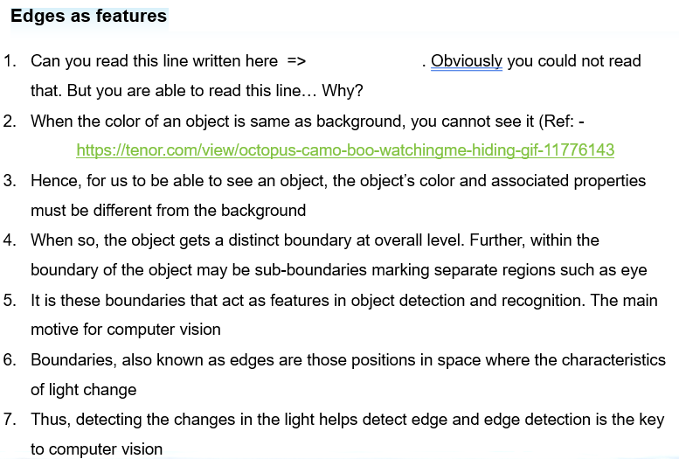

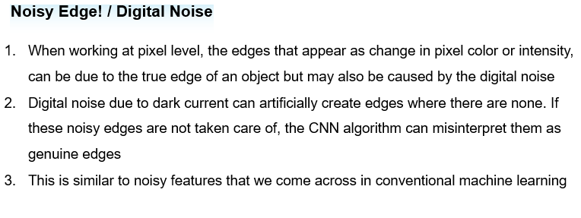

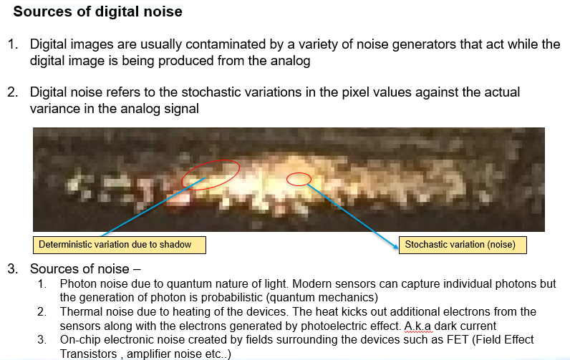

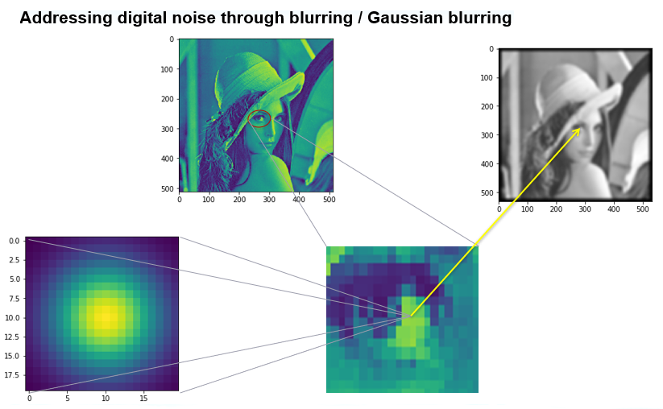

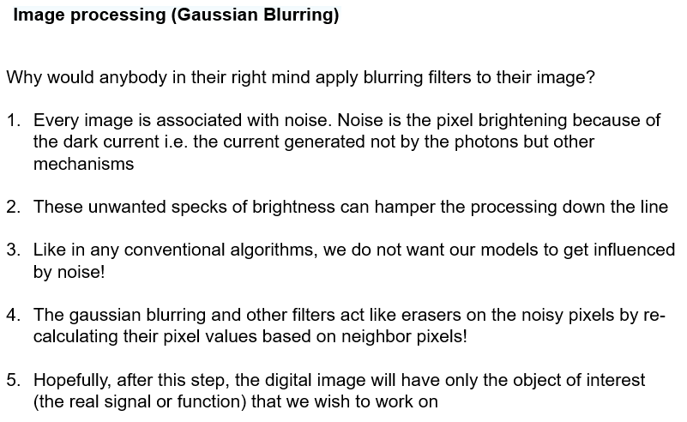

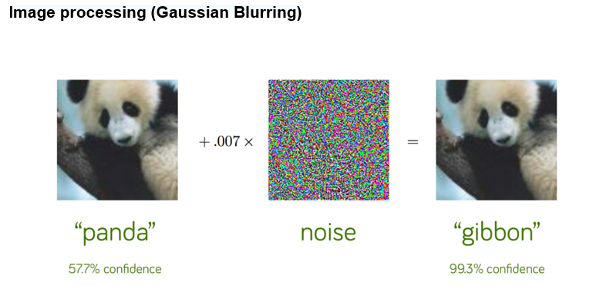

https://www.kdnuggets.com/2019/03/breaking-neural-networks-adversarial-attacks.html



# Convolutional Neural Networks

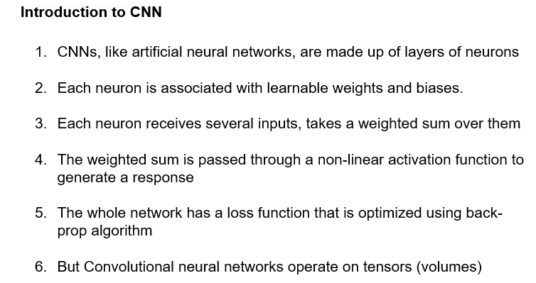

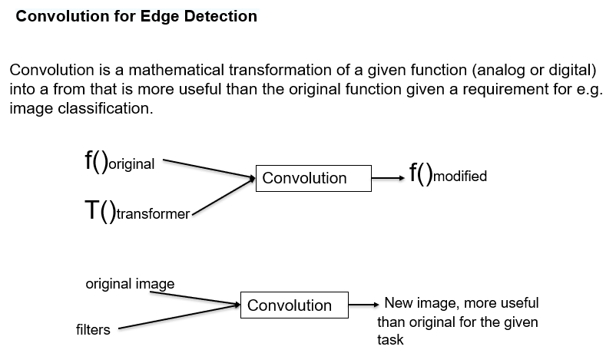

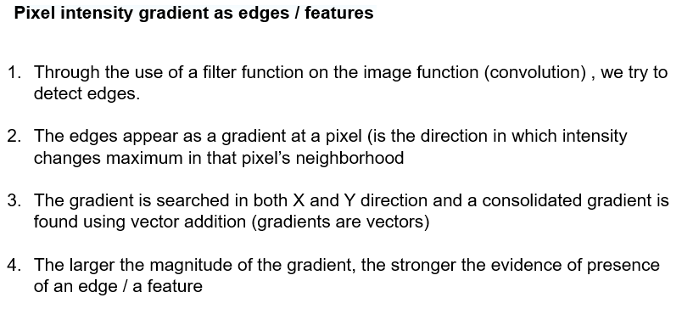

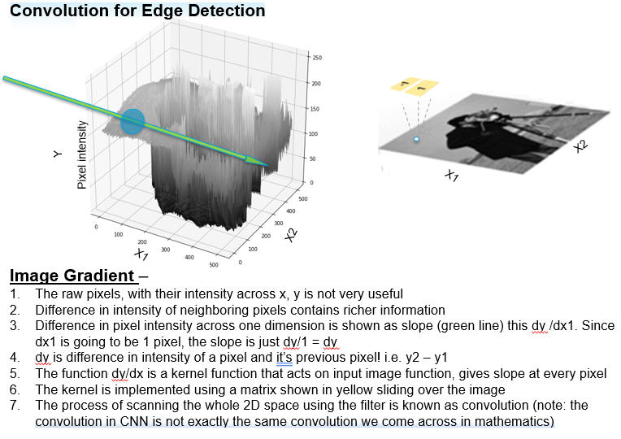

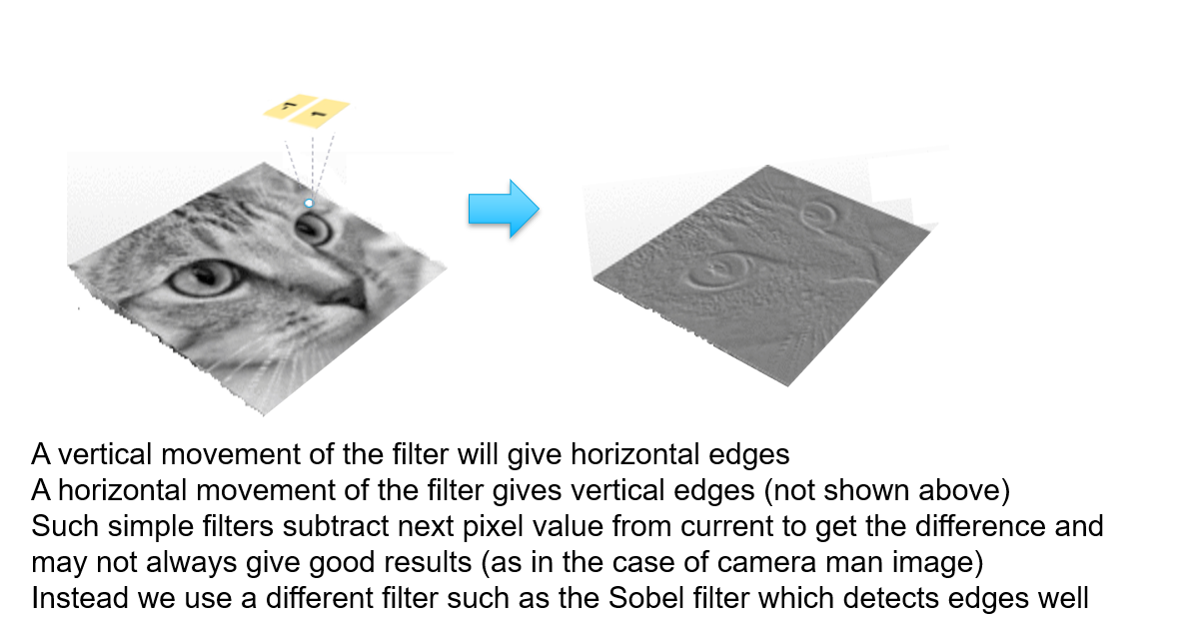

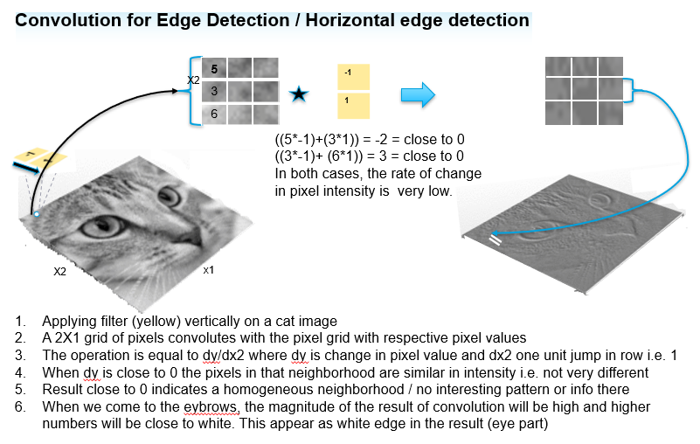

# ANN Vs cnn (Why ANN is not suitable for image processing)

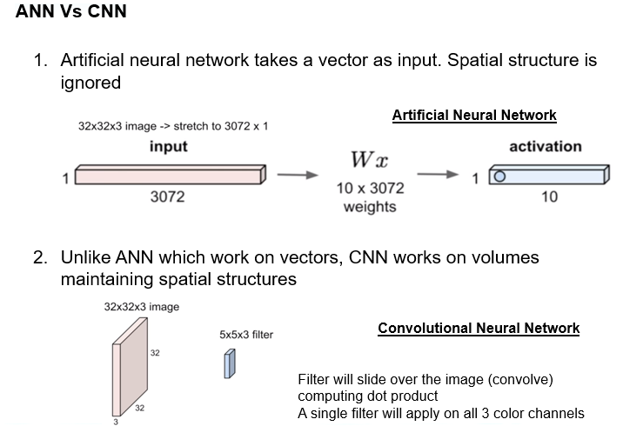

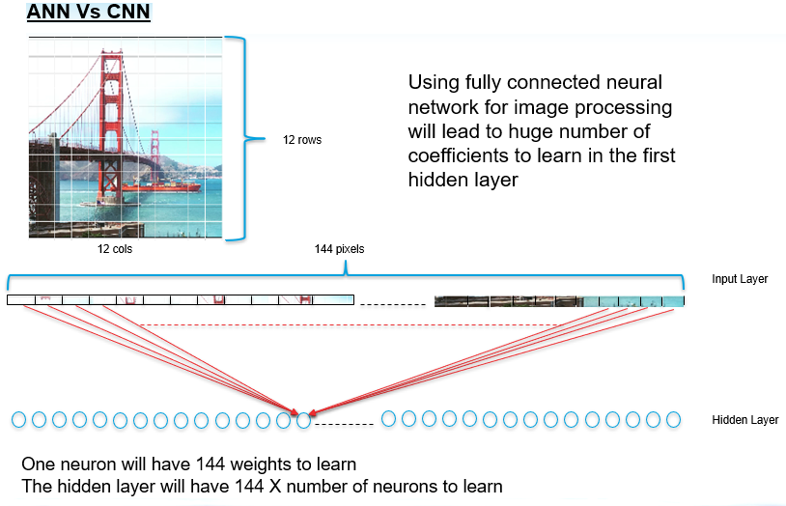

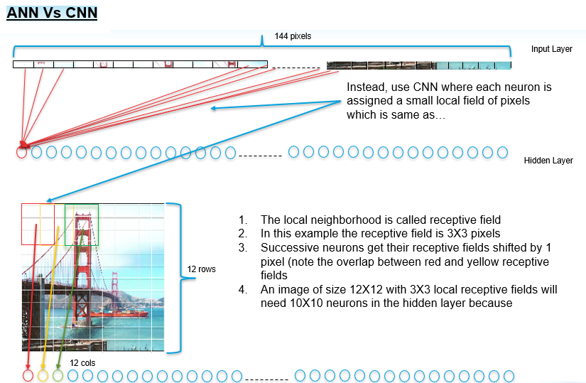

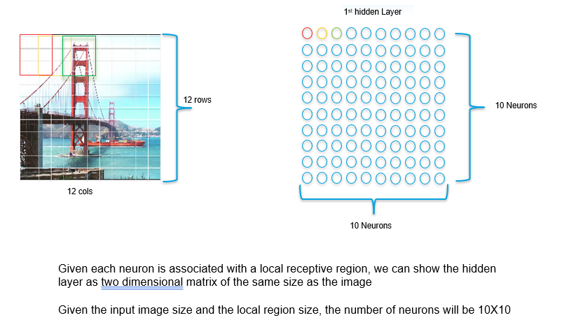

# Convolution Formal Definition

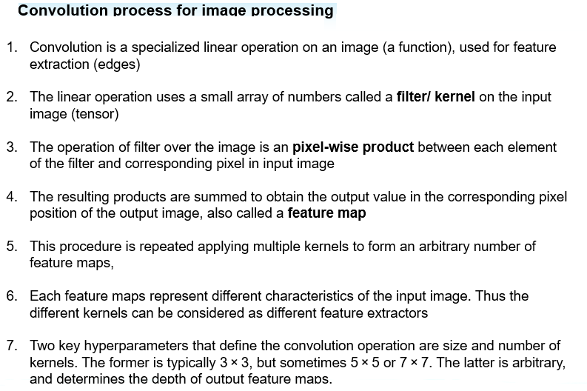

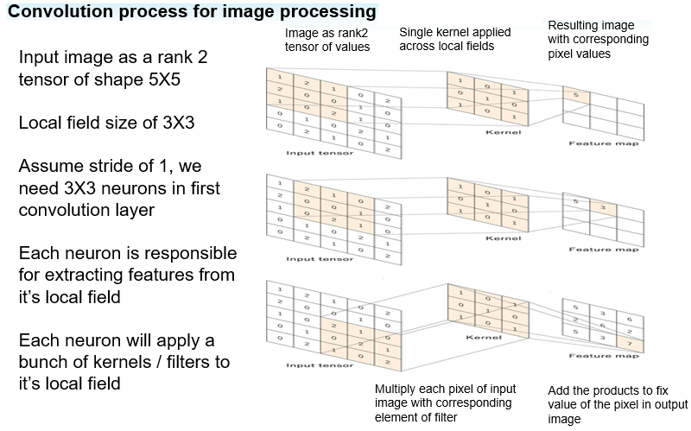

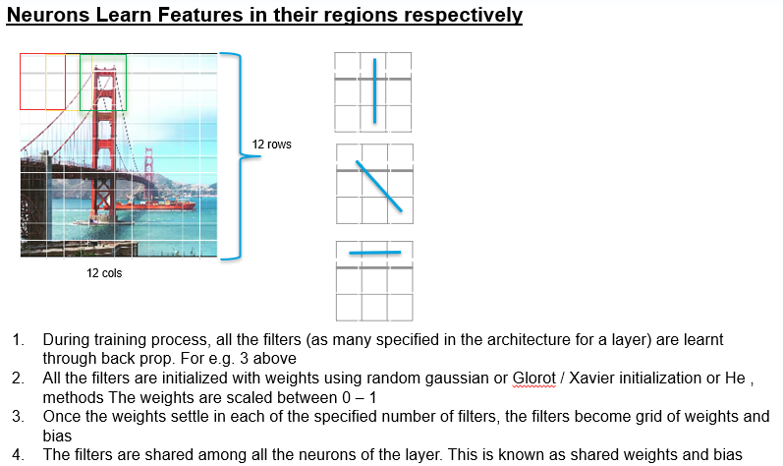

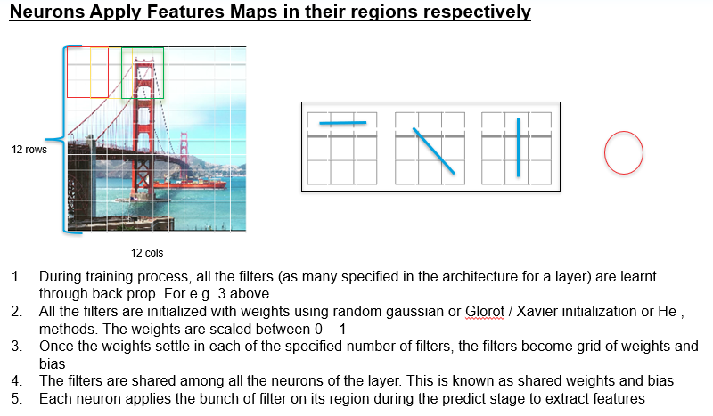

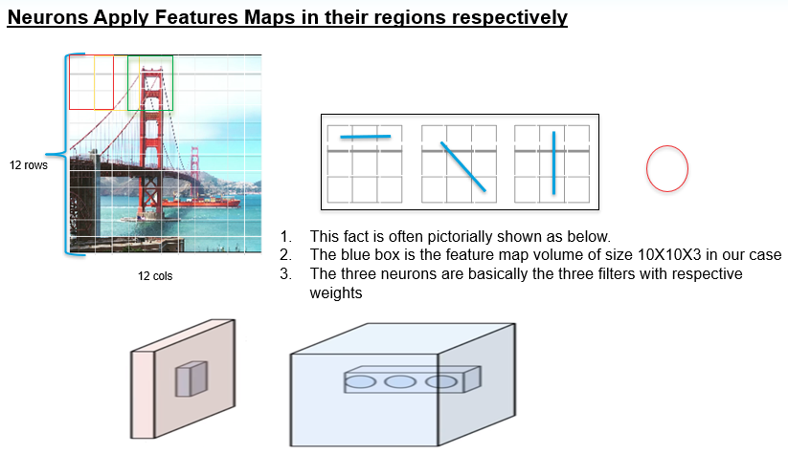

# filters for edge detection

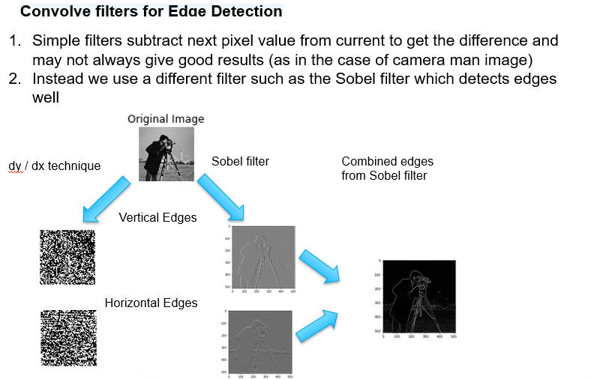

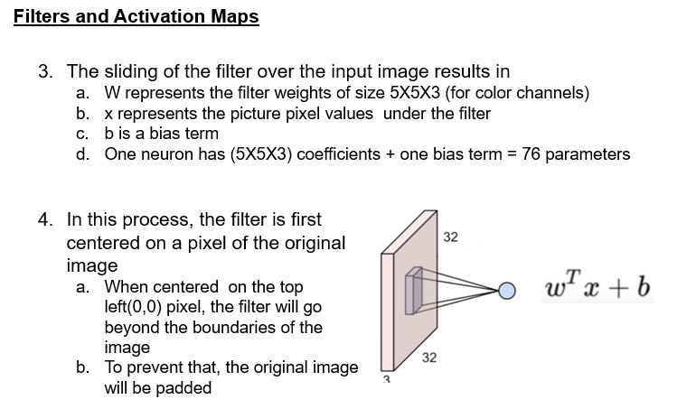

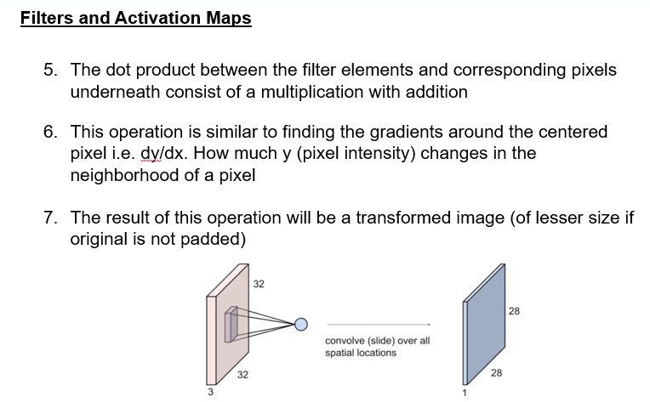

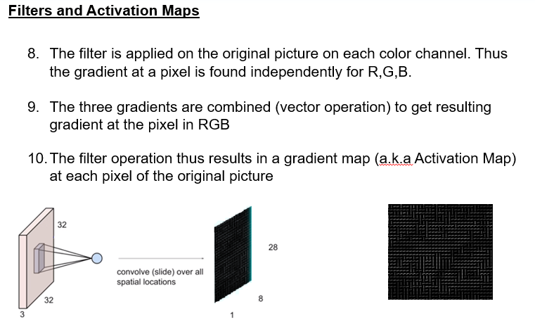

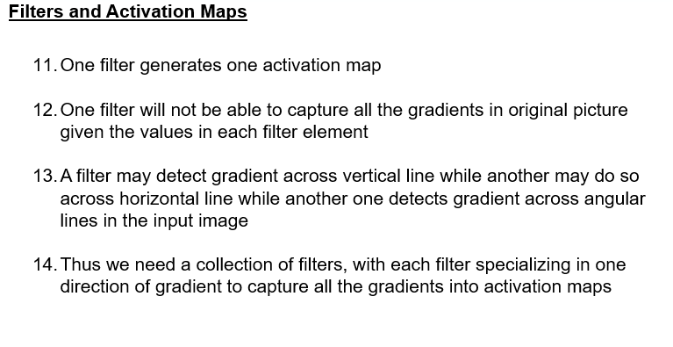

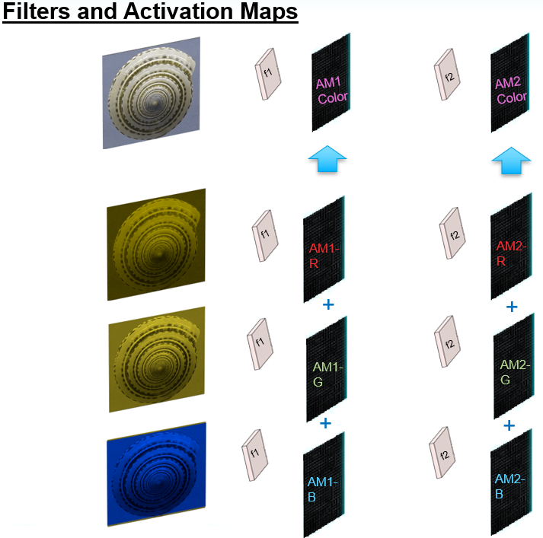

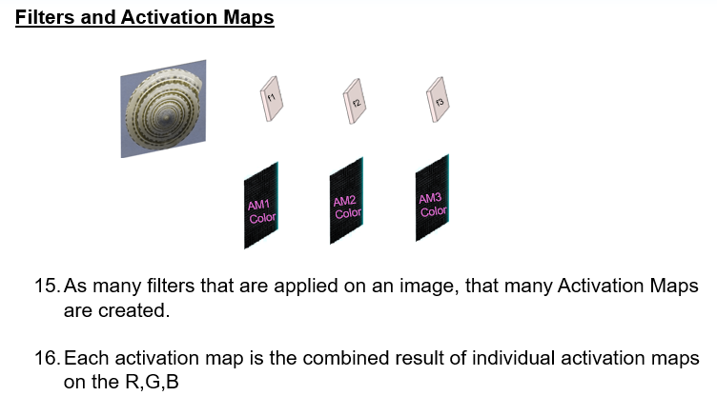

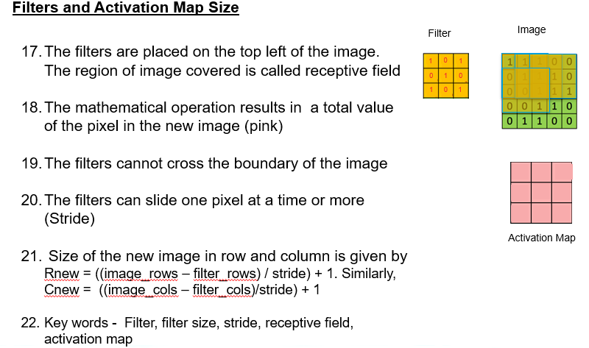

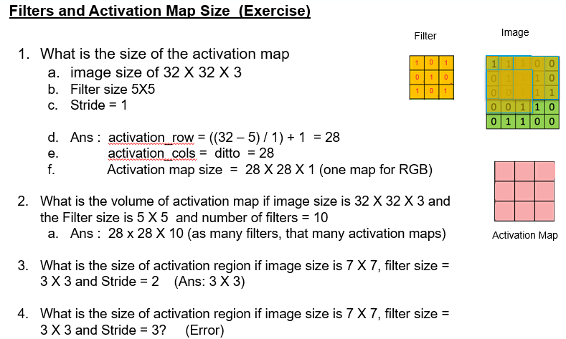

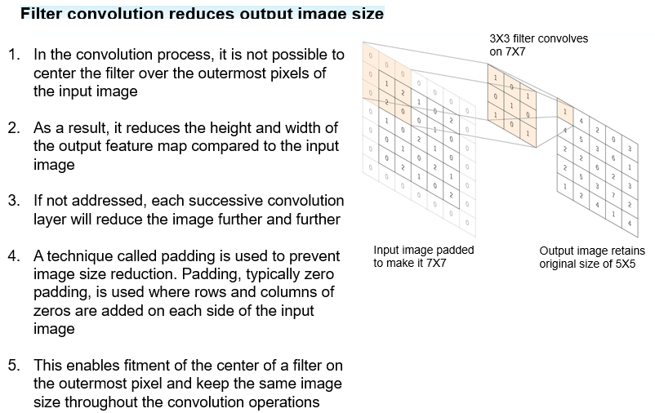

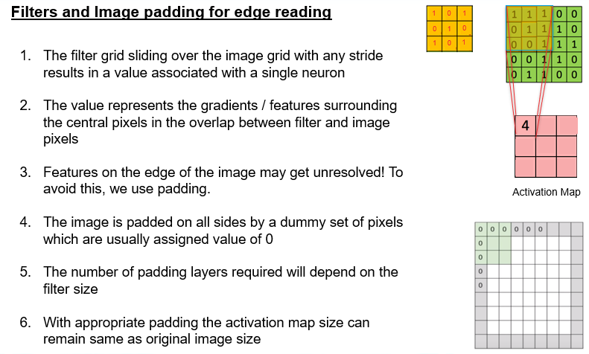

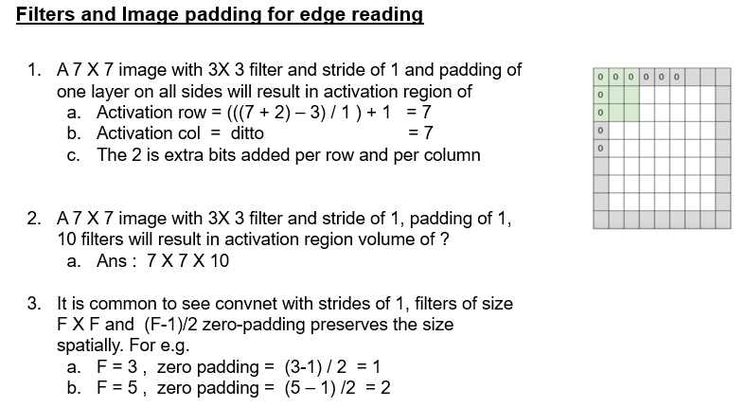

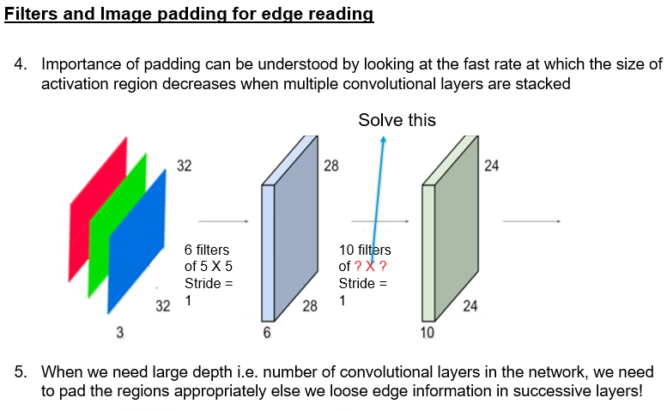

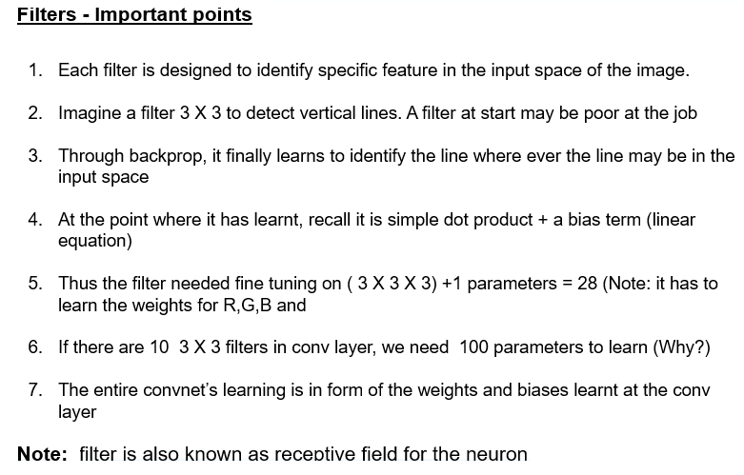

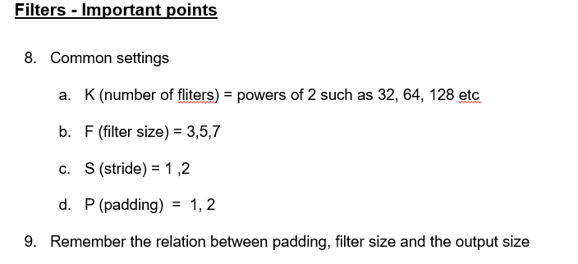

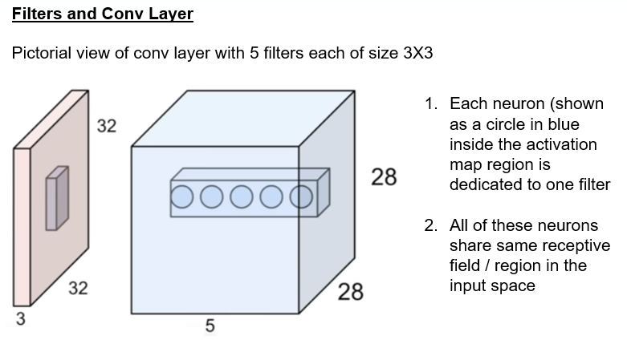

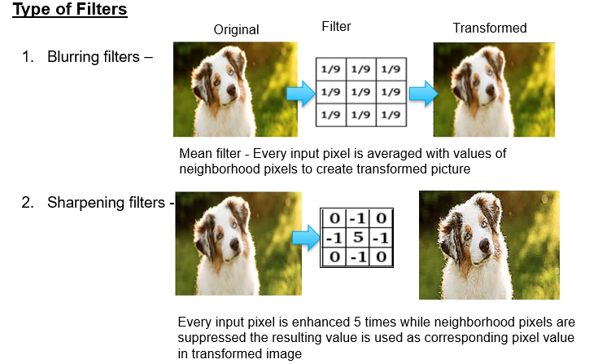

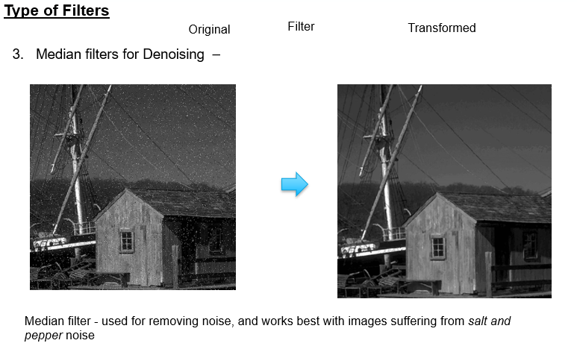

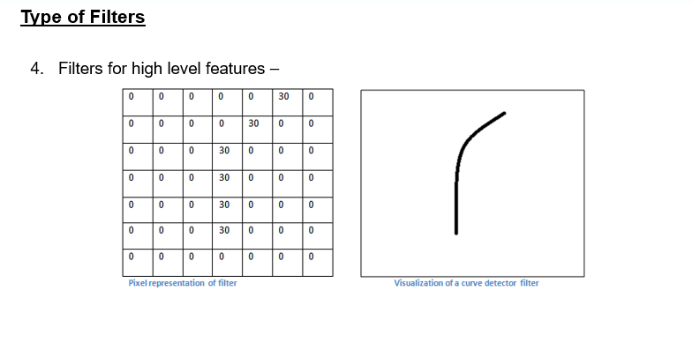

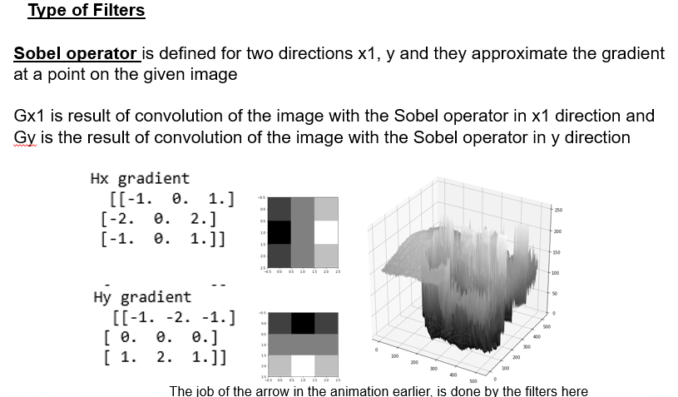

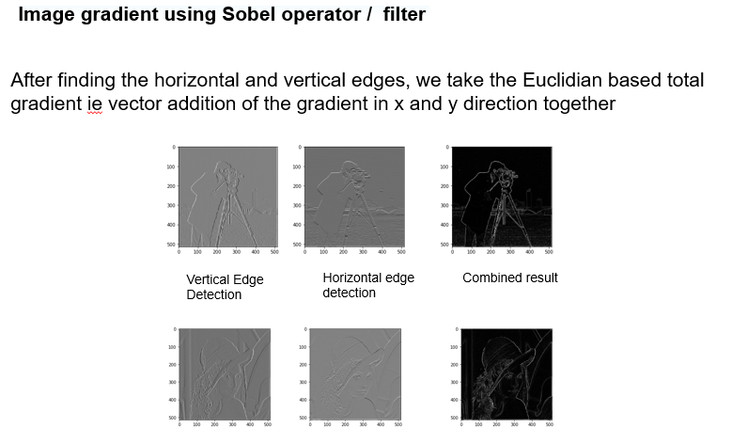

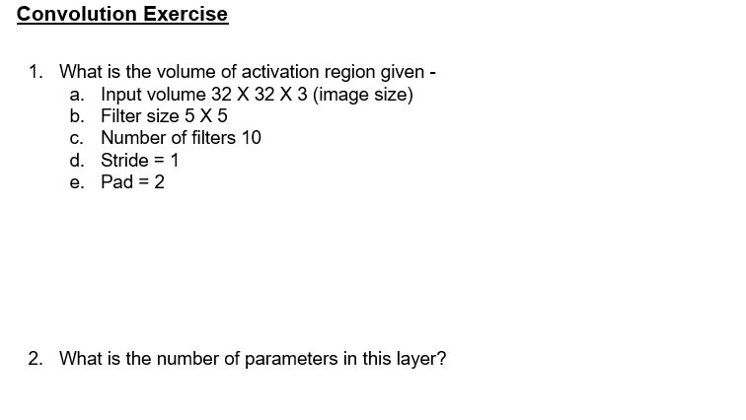

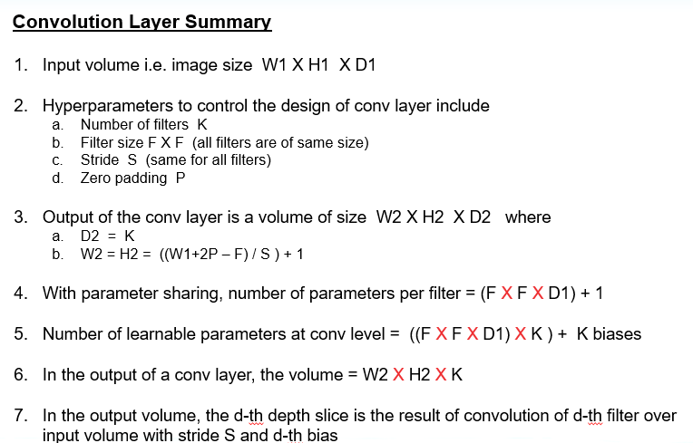

# RELU As NonLinear Activation Function

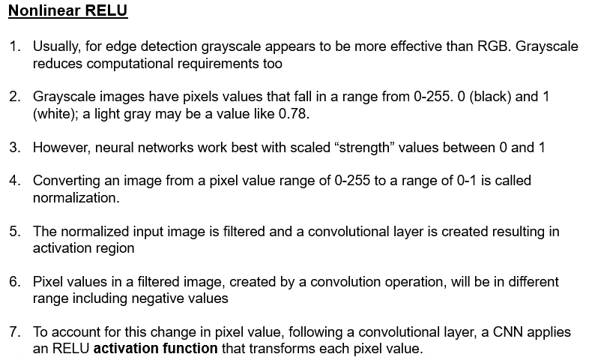

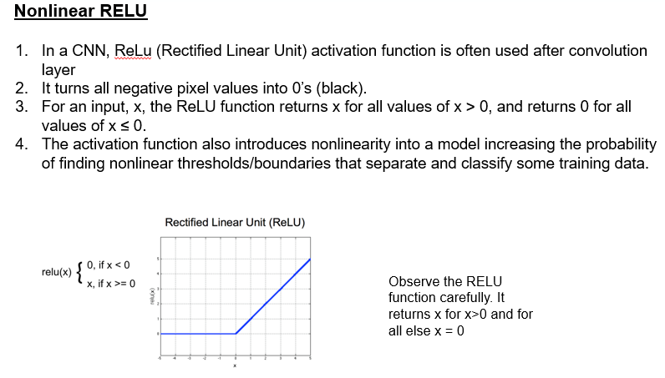

# Pooling layer

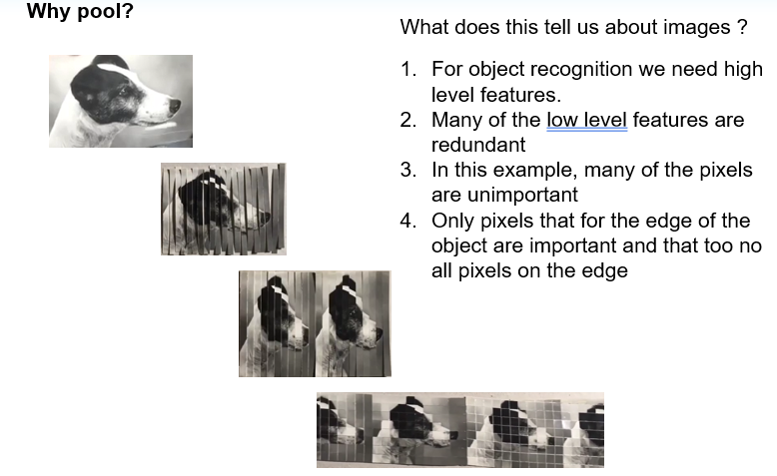

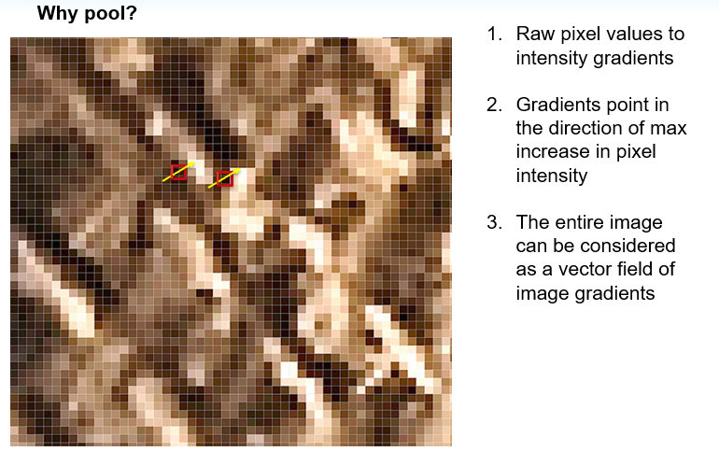

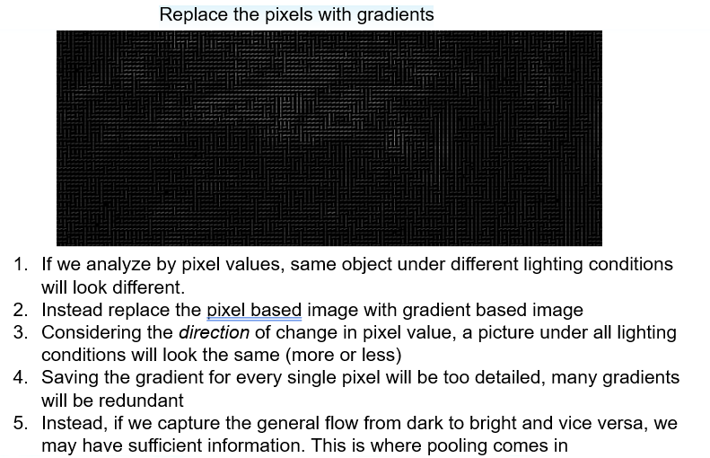

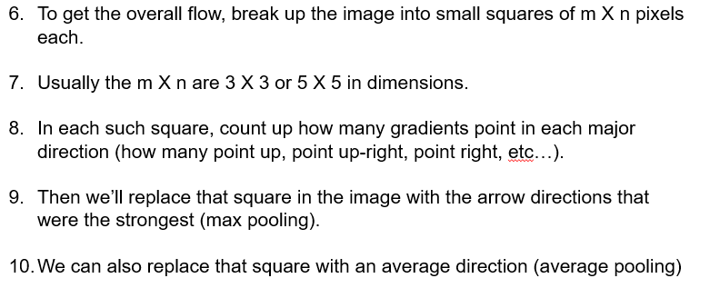

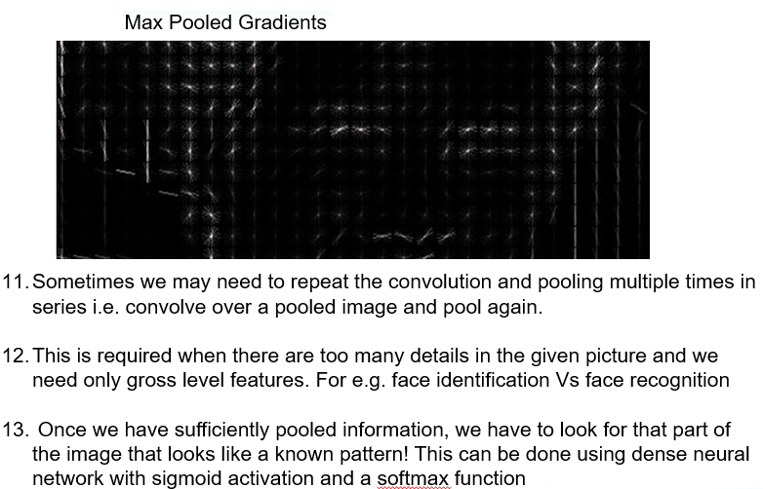

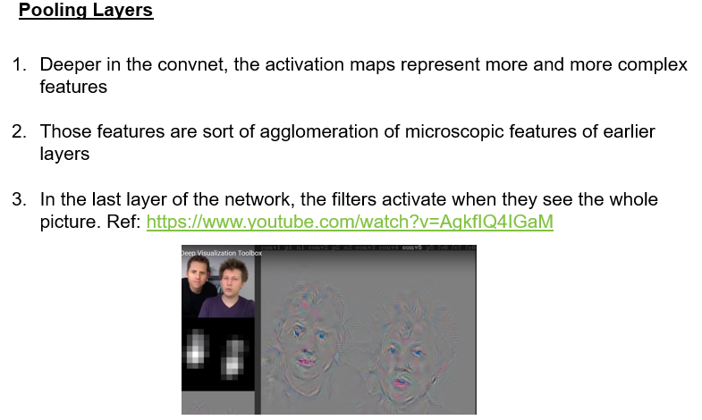

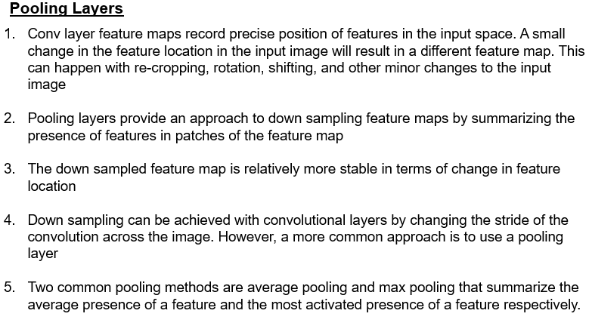

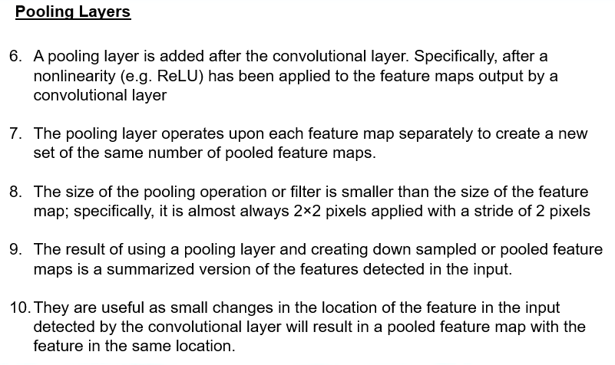

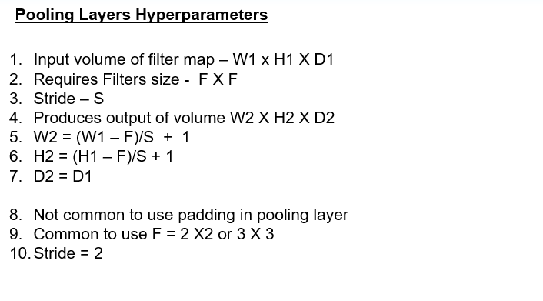

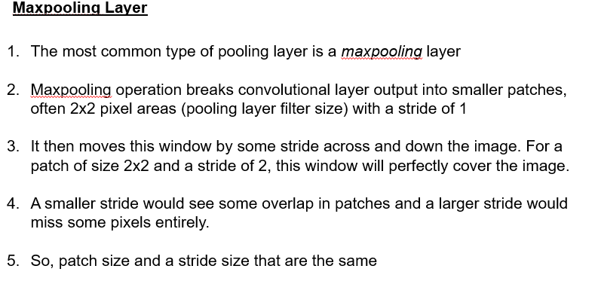

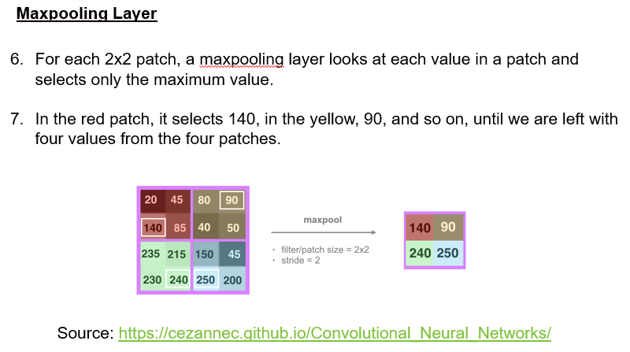

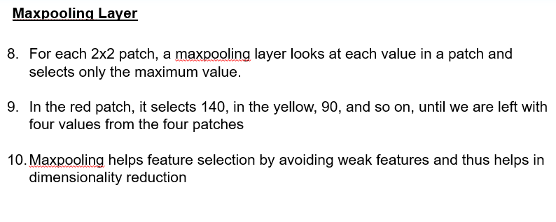

# Fully Connected layer

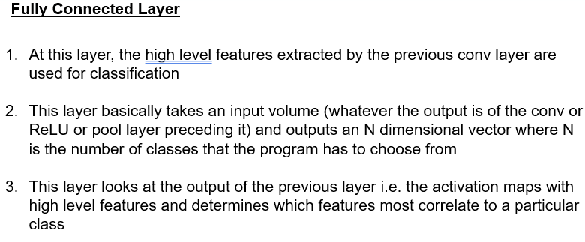

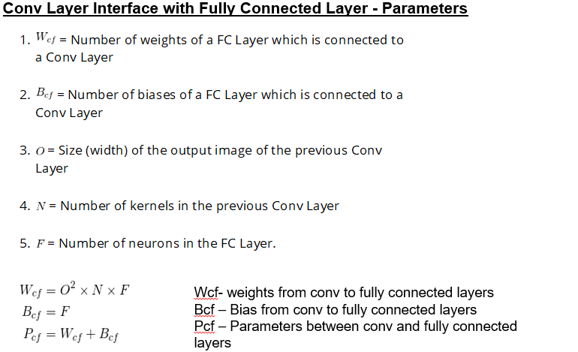

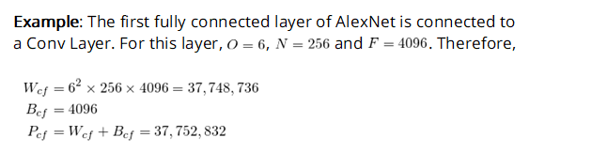

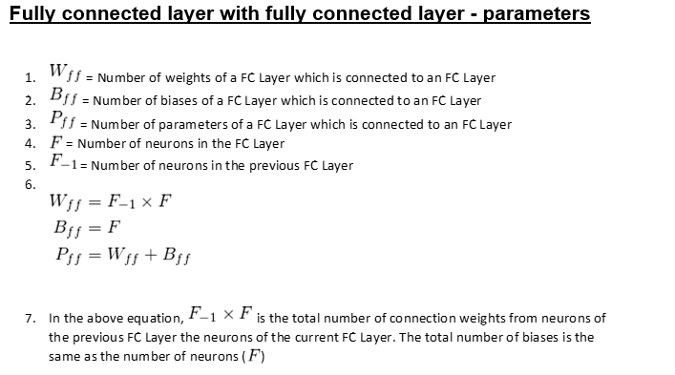

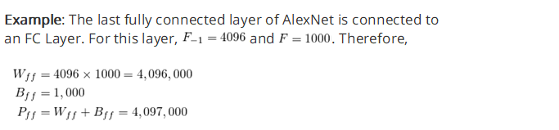

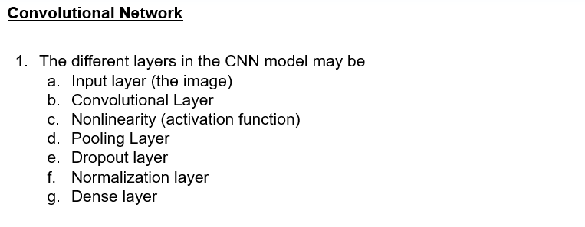

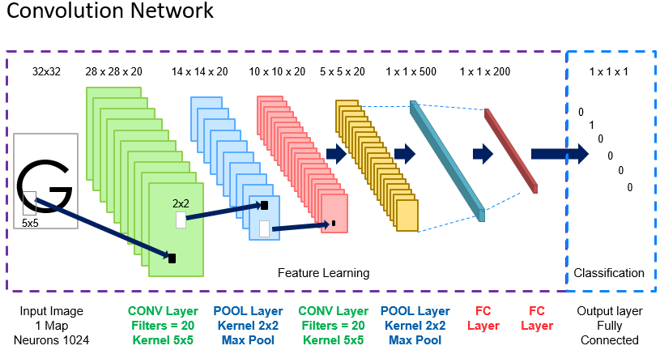

# CNN in keras … step by step

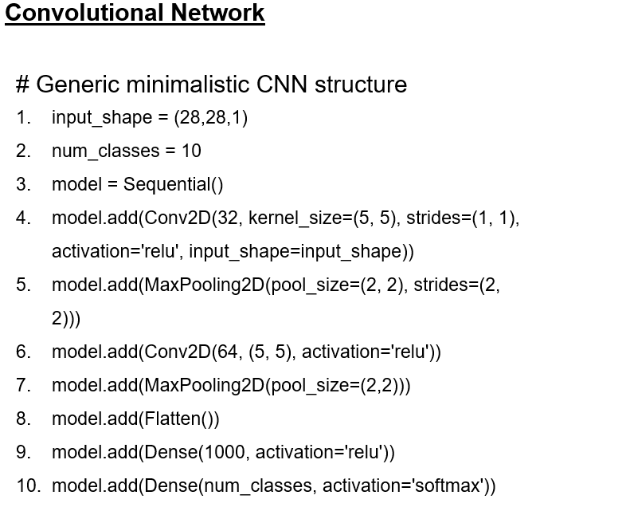

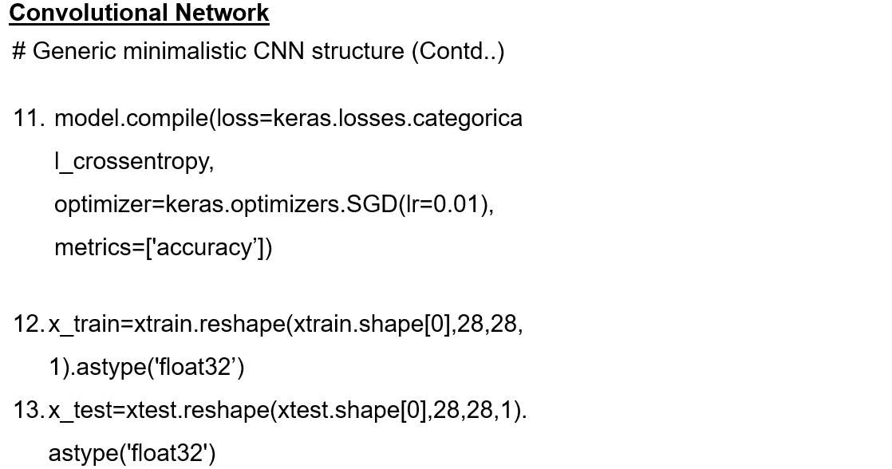

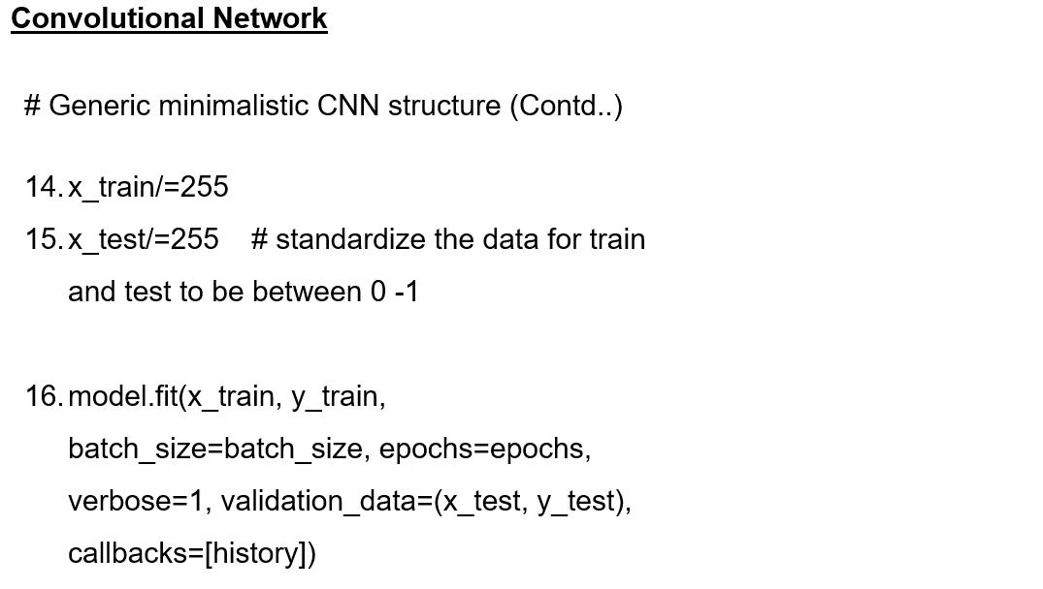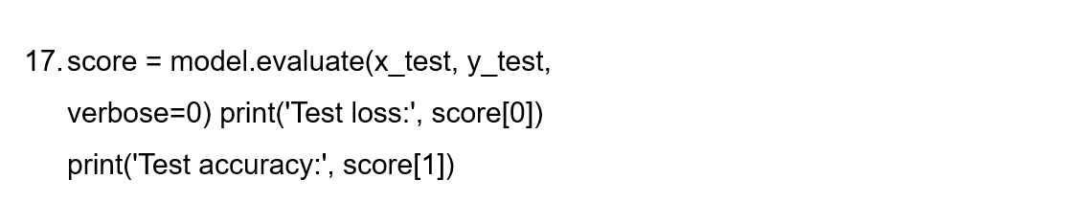

# CNN architectures

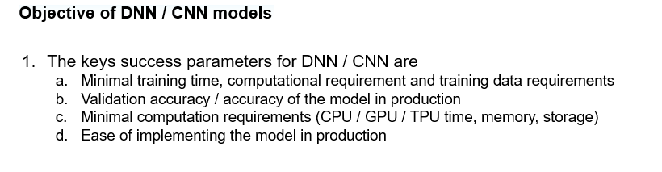

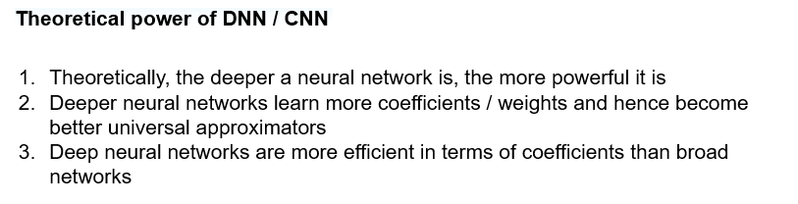

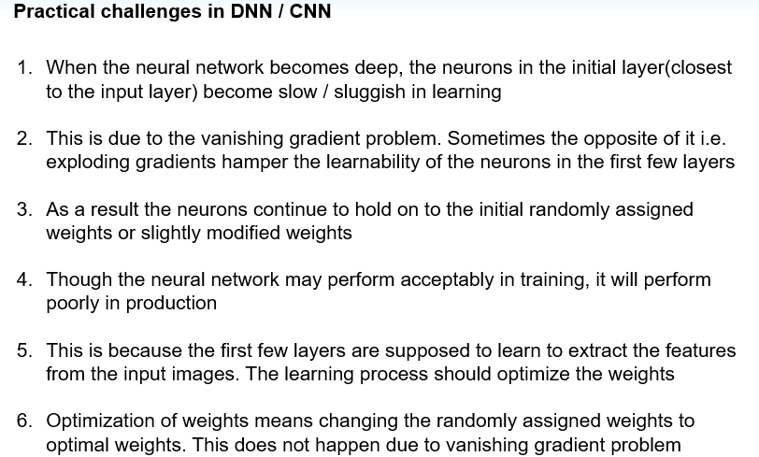

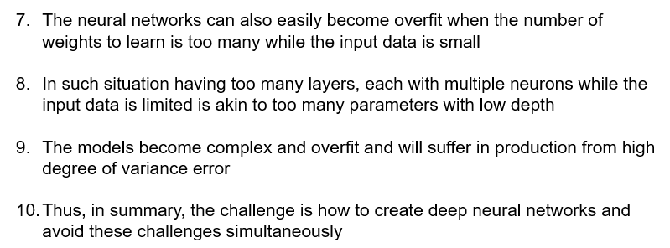

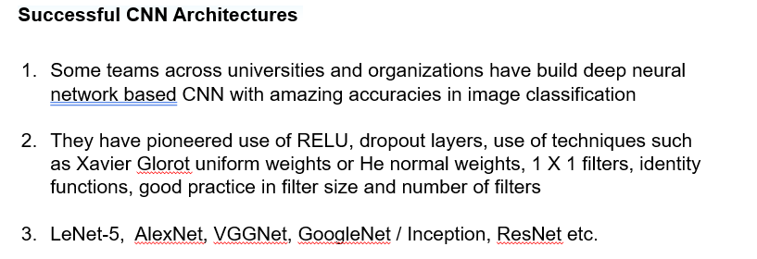

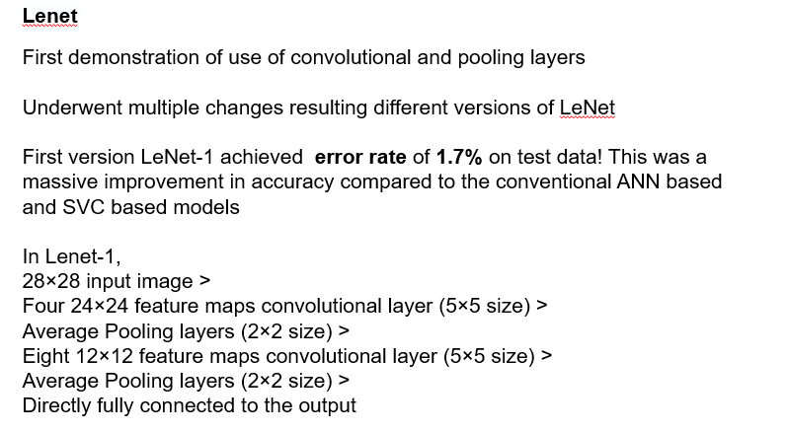

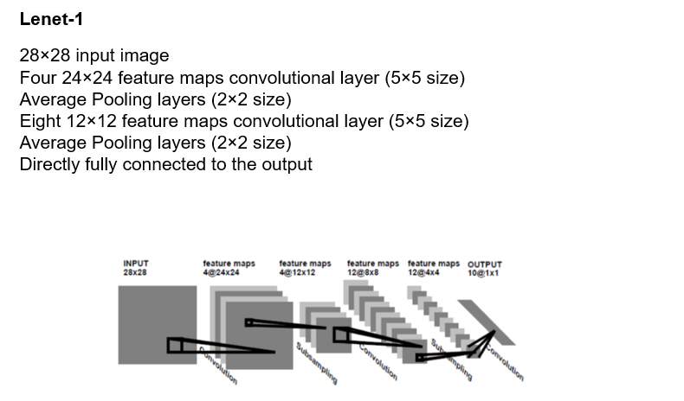

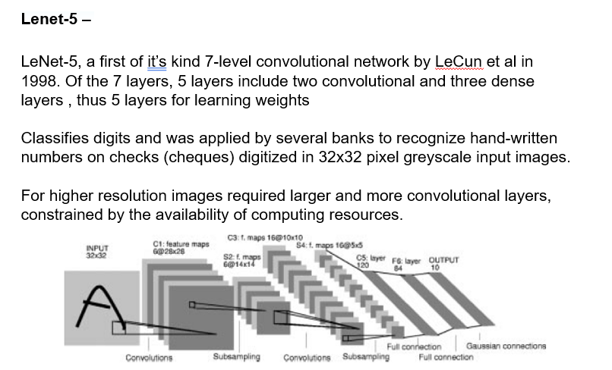

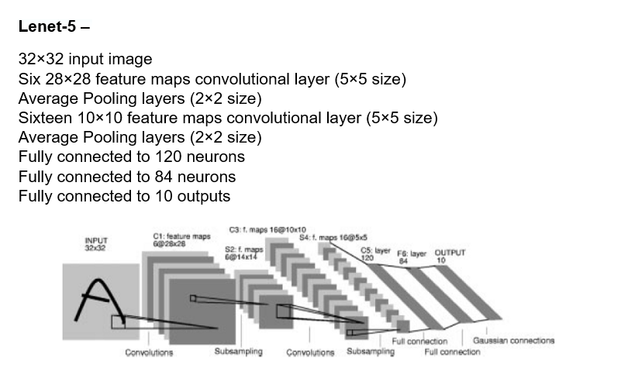

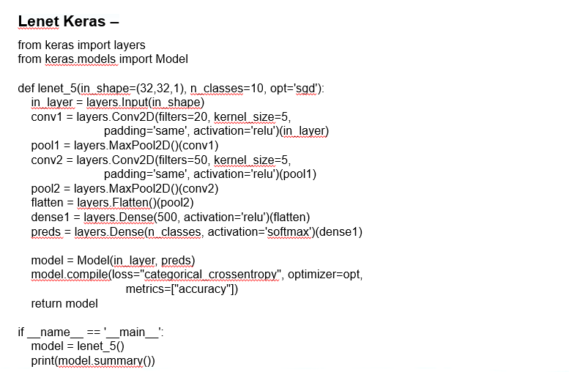

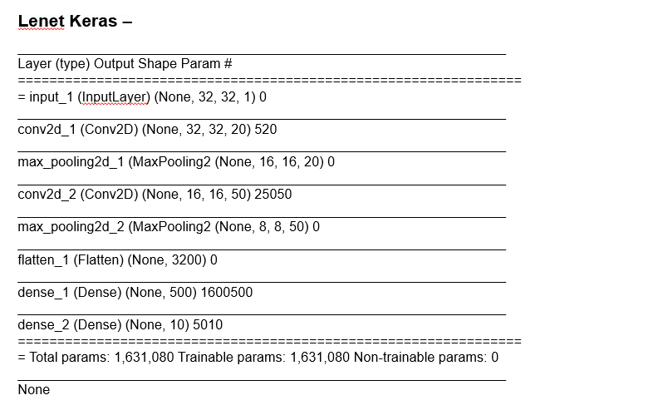

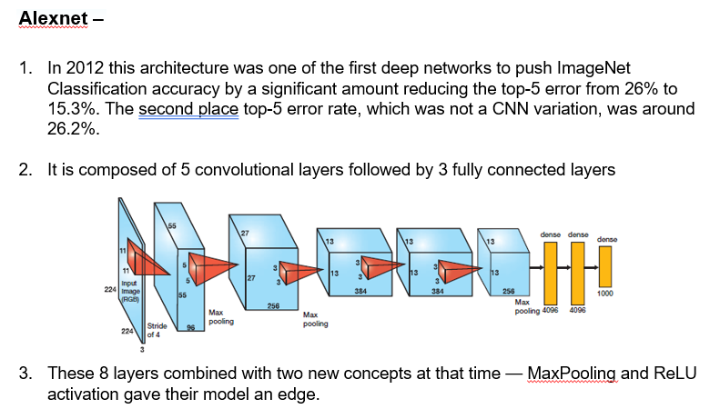

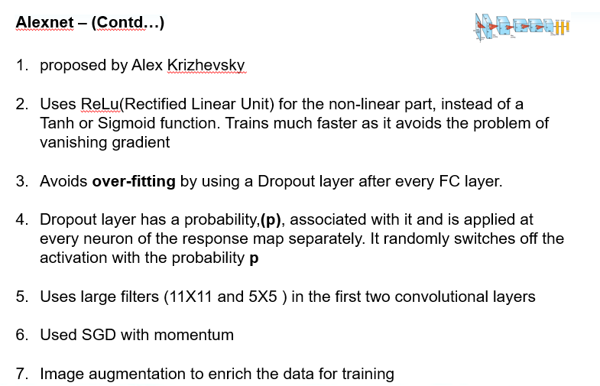

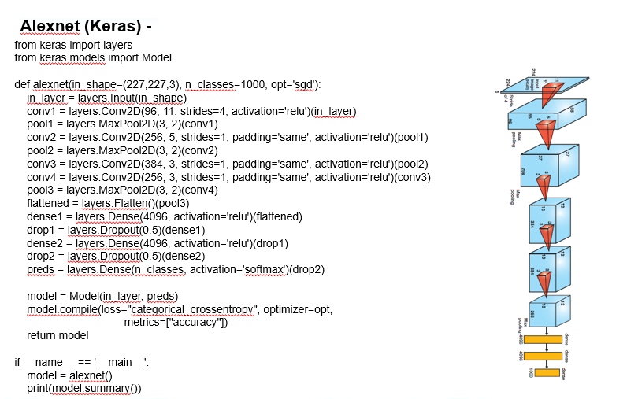

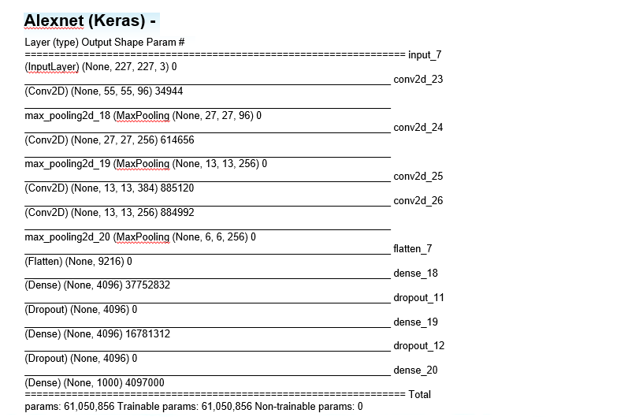

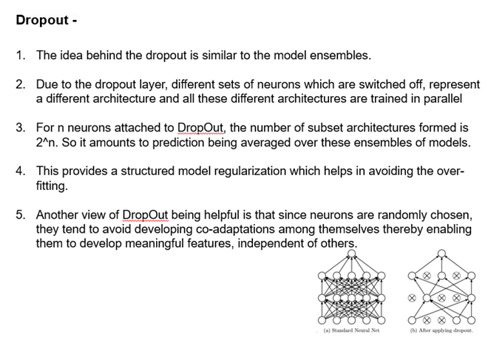

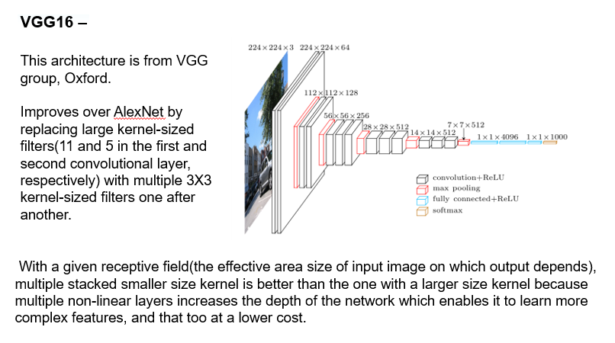

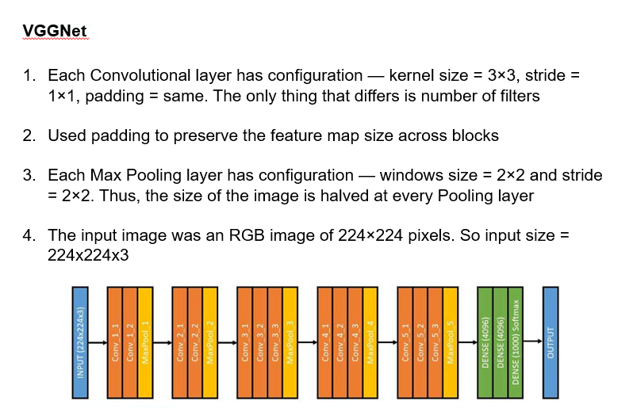

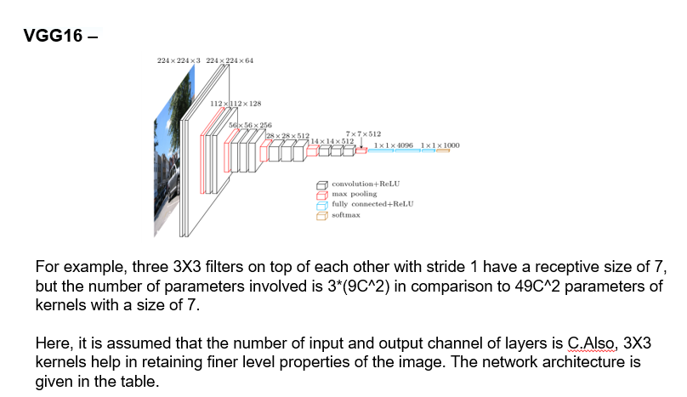

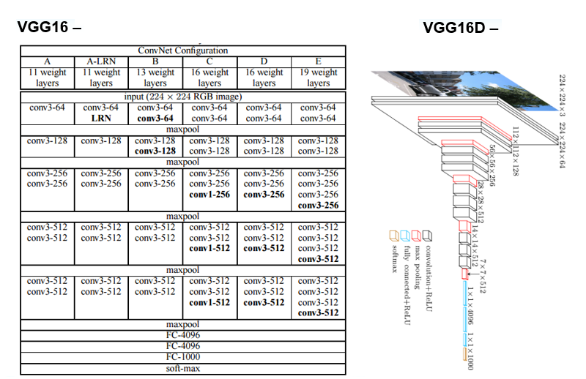

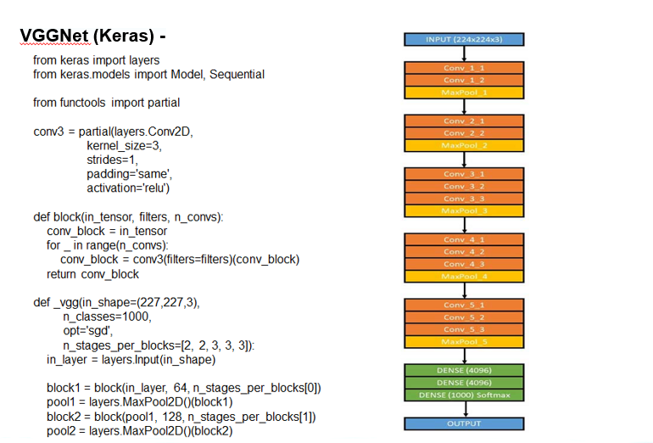

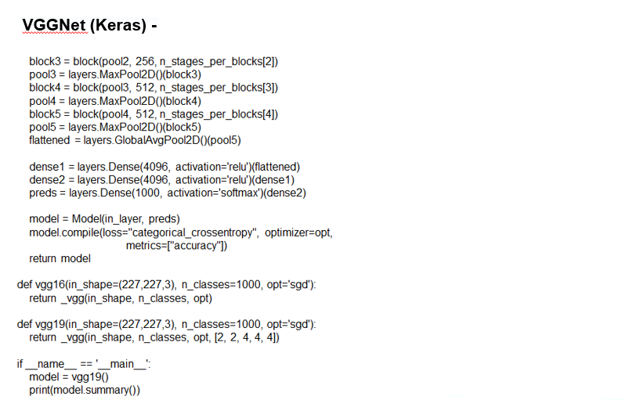

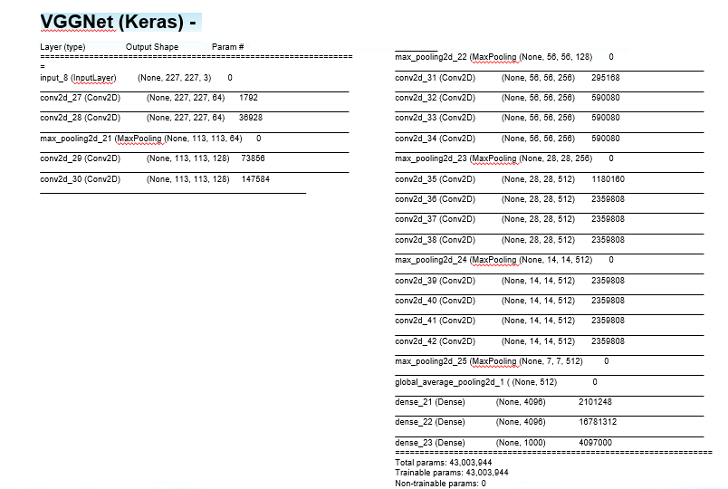

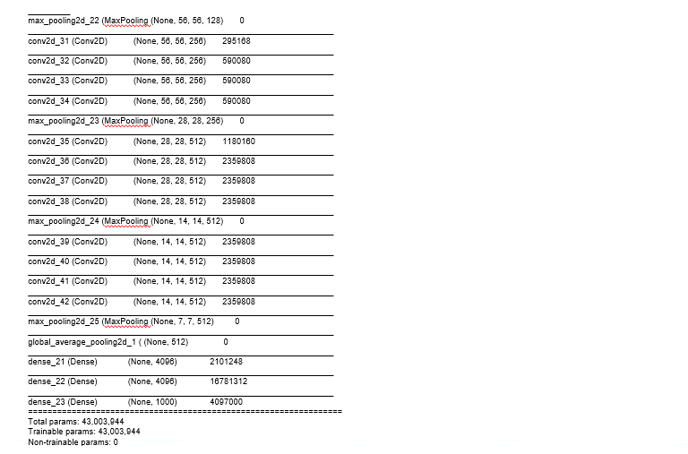

# Transfer learning

